



SCHOOL UNIFORM POLICY

Policy Date: September 2026

Review Date: September 2027

Purpose and principles
Our uniform helps children feel that they belong at our school, supports equality and creates a practical, calm approach to the school day. This policy is designed to be affordable, inclusive and easy for families to follow. Cost must never prevent a child from applying to, attending or taking part fully in school.
This policy follows Department for Education rules and guidance on keeping school uniform costs affordable, updated in July 2026. It also follows the Equality Act 2010 and the Human Rights Act 1998.

Our uniform
The following requirements apply to children in Reception to Year 4. Families may buy all generic items from any retailer.

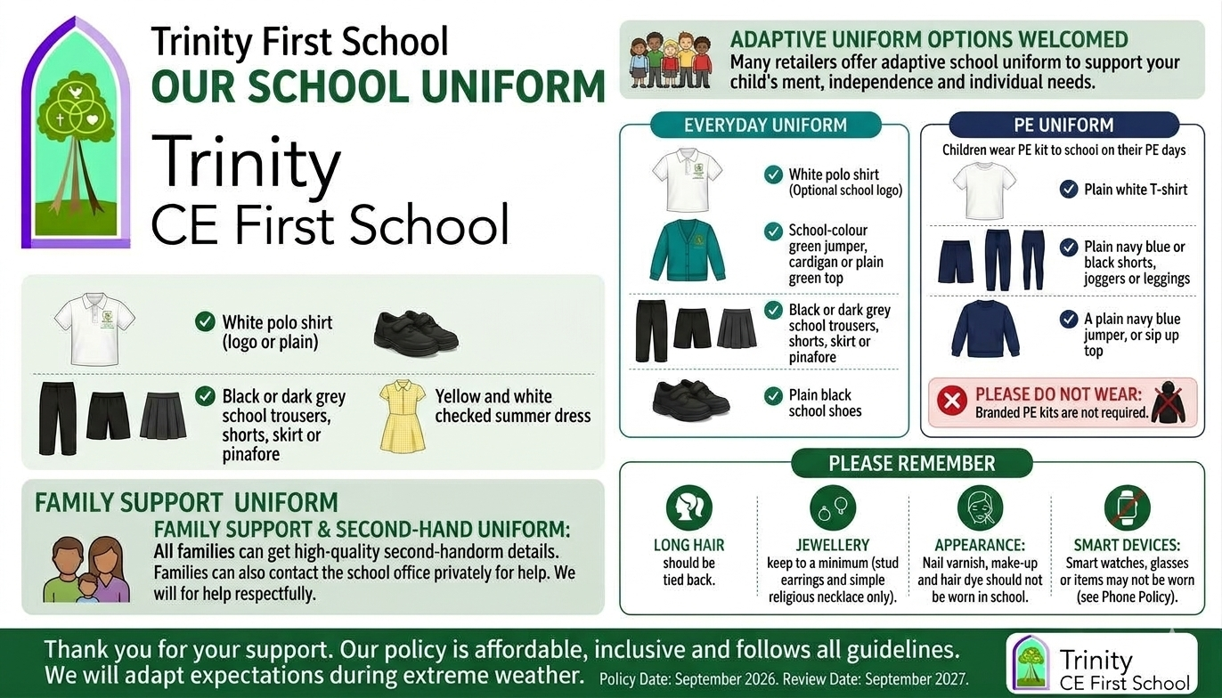

Item | Specification | Status | Branding
Everyday top | White polo shirt | Required | Plain or optional school logo
Warm layer | School colour green sweatshirt, jumper or cardigan | Required as needed | Plain or optional school logo
Lower Garment | Black or dark grey trousers, shorts, skirt or pinafore | Required | Generic
Footwear | Plain black, safe, closed-toe school shoes | Required | Generic
Additional Option | In the warmer months, yellow and white checked summer dress | Optional | Generic
Outdoor clothing | A practical coat suitable for the weather | Required as needed | Generic; any safe, sensible colour

PE kit
Children wear their PE kit to school on their allocated PE days. All items may be purchased from any retailer and must be comfortable and suitable for physical activity.
Item | Specification | Status
Top | Plain white T-shirt | Required
Lower garment | Plain navy blue or black shorts, joggers or sports leggings | Required
Warm layer | A plain navy blue jumper, or zip up top | As needed
Footwear | Trainers suitable for PE | Required

A separate branded PE kit is not required. The school will loan specialist team kit where it is needed for competitions. No child will be prevented from taking part in PE or representing the school because of uniform cost or a temporary uniform difficulty.

Appearance and safety
- Long hair must be tied back. Hair may be worn in any natural or protective style that is safe for school activities.
- Small stud earrings may be worn. Other jewellery is not permitted, except a simple religious necklace or article agreed with the school. Jewellery may need to be removed or secured for PE and practical activities.
- Nail varnish, make-up and dyed hair are not part of school uniform.
- Clothing, bags and accessories should not display offensive, discriminatory or party-political wording or imagery.
- All clothing and footwear should be safe, practical and clearly named.
- In line with our Phone Policy, smart devices such as watches, glasses or other items may not be worn.

Affordability and branded items
We do not require any clothing with the school logo. Families may order polo shirts, sweatshirts, jumpers or cardigans with the logo from our supplier, but they can always choose the same item without a logo. To keep uniform affordable, the school will:
- Keep the number and cost of compulsory items to a minimum and consider the total cost to families when this policy is reviewed;
- Avoid requiring additional uniform for clubs, trips, performances or competitions;
- Allow enough notice and a reasonable transition period if requirements change;
- Review any uniform-supply arrangements for cost, quality, durability and value for money; and
- Publish clear uniform and second-hand arrangements on the school website for current and prospective families.

Second-hand uniform and support
All families can get good-quality second-hand uniform. The school website will explain where to find it and how to request it, including for families whose children have not yet joined the school. Families can also contact the school office privately for help.
If paying for uniform is difficult, please speak privately to the school office or a class teacher. The school may be able to provide or lend items, help you find second-hand uniform, or agree that your child can wear something different for a short time. We will offer help privately and respectfully.

Equality, religion and individual needs
All children may choose from the uniform options. We will consider changes where a child needs them. This includes reasonable adjustments for disabled children and children with special educational needs, sensory needs or medical conditions. Children may wear adaptive uniform.
We will do our best to meet a child’s religious or cultural needs, including dress, hairstyles, head coverings and articles of faith. We will only limit these where there is a genuine health, safety or safeguarding reason, and any limit will go no further than necessary. Families should speak with the Headteacher so that we can agree a suitable arrangement together.

Weather and exceptional circumstances
The Headteacher may temporarily adapt uniform expectations during extreme or adverse weather or where this supports a child’s attendance, health or wellbeing. Children may wear practical outerwear needed to travel safely to and from school, including visible or reflective clothing in poor light.

When uniform expectations are not met
Staff will deal with uniform concerns calmly, privately and fairly. Before taking any further action, they will check whether there is a reason outside the child’s control. This could include cost, a medical or sensory need, religion or culture, or a safeguarding concern. Where helpful, the school will contact parents and find a practical solution, such as lending an item or agreeing a temporary change.
We will deal with uniform concerns fairly and in line with the school’s behaviour policy. A child will not miss lessons, breaktime, PE, a club or any other part of school life because their family cannot afford the correct uniform. If the school considers a formal consequence, it must follow the behaviour policy and relevant legal guidance.

Roles and responsibilities

Academy Standards and Ethos Committee (ASEC – local governors)
The ASEC checks that this policy follows government guidance and the law. It also checks that the uniform is affordable and considers how the policy affects different groups of children.

The Headteacher and school staff
The Headteacher implements the policy fairly, ensures reasonable adjustments and support are considered, and keeps uniform information current and accessible. Staff model and reinforce expectations consistently, avoid public correction or shaming, and raise any concern about hardship, discrimination or wellbeing with the appropriate leader.

Parents and carers
Parents and carers are asked to provide the required uniform, label items, contact the school early if support or an adjustment is needed, and work with the school to resolve concerns.

Children
Children are expected to wear the agreed uniform, look after their belongings and speak to a trusted adult if they need help or feel uncomfortable or unfairly treated.

Consultation, publication and review
We will ask parents and children for their views when we develop this policy or plan a major change. We will pay particular attention to cost and to whether a change could affect some groups of children differently. The final policy will be easy to find on the school website and will be available to families whose children have not yet joined the school. We will review it at least once a year, and sooner if the law, government guidance or local circumstances change.

Complaints
If you have a question or concern, please speak to the Headteacher first so that the school and your family can try to agree a solution. If the issue is not resolved, you can make a formal complaint using the school’s published complaints procedure. If your concern is about the supplier’s service or the quality of an item, you can also use the supplier’s complaints process.

Related documents and guidance
- Behaviour Policy
- Complaints Procedure
- Equality information and objectives
- Department for Education Cost of school uniforms statutory guidance updated 6 July 2026
- Department for Education Developing school uniform policy guidance updated 6 July 2026
- Equality Act 2010 and Human Rights Act 1998

